

**ARIFU: A IMAGE RECOGNITION DISEASE DETECTION APP AND USSD PLATFORM FOR FARMERS**

**School Of Computing And Engineering Sciences**

Student Number: 137938

An Informatics and Computer Science Project Proposal Submitted to the School of Computing and Engineering Sciences in partial fulfillment of the requirements for the award of a Degree in Bachelor of Science in Informatics and Computer Science.

Date of Submission: 23th May 2024

Declaration and Approval

I declare that this project has not been submitted to Strathmore University or any other University for the award of a Degree in Bachelor of Science in Informatics and Computer Science or any other Degree.

Student Number: 137938

Signature:



Date: 23th May 2024

Supervisor’s Name: Mr. James Gikera

Signature:



Date: 23th May 2024

Abstract

The proposed "Arifu" initiative seeks to revolutionize agricultural knowledge dissemination among Tanzanian farmers, leveraging the ubiquity of SMS services and a mobile application. Targeting farmers without access to smartphones or the internet and also those with, the project will deliver tailored visual content and SMS content covering vital aspects of crop cultivation. With a concise format and language accessible to all, Arifu aims to democratize agricultural education, fostering a community of informed farmers capable of improving yields and livelihoods.

Arifu utilizes cutting-edge technology to deliver agricultural insights directly to farmers' feature phones, ensuring accessibility even in remote areas with limited connectivity. By providing concise yet comprehensive information on land preparation, seedling production, fertilization, pest and disease management, and post-harvest practices, the platform empowers farmers to address challenges and implement best practices effectively.

Through interactive SMS exchanges, rural farmers can access real-time solutions to pressing agricultural issues, such as pest infestations or soil nutrient deficiencies. By leveraging machine learning algorithms and user feedback, Arifu continuously refines its content to better meet farmers' evolving needs, ensuring relevance and efficacy in knowledge delivery.

As farmers adopt and share these insights within their communities, Arifu catalyses a grassroots movement of knowledge exchange and innovation, driving sustainable agricultural practices and economic empowerment. By democratizing access to expert agricultural guidance, Arifu lays the foundation for a more resilient and prosperous farming sector in Tanzania.

***Keywords: Arifu, SMS, agricultural education, knowledge dissemination, smallholder farmers, SMS platform, Tanzania, technology, digital solutions, innovation, sustainability***

Table of Contents

Declaration and Approval ii

Abstract iii

List of Figures vi

List of Abbreviations vii

Chapter 1: Introduction 1

1.1 Background Information 1

1.2 Problem Statement 2

1.3 Objectives 3

1.3.1 General Objective 3

1.3.2 Specific Objectives 3

1.3.3 Research Questions 3

1.4 Justification 4

1.5 Scope and Limitations 4

Chapter 2: Literature Review 6

2.1 Introduction 6

2.2 Agricultural Information Dissemination in Tanzania 6

2.2.1 Challenges in Agricultural Knowledge Dissemination 6

2.3 Existing Agricultural Information Solutions 7

2.3.1 2.4.1 WeFarm 7

2.3.2 iCow 8

2.3.3 DigiFarm 9

2.3.4 eSoko 10

2.4 Gaps in Existing Solutions 11

2.4.1 Limited Real-time Interaction 11

2.4.2 Scalability and Coverage 11

2.4.3 Customization and Personalization 11

2.4.4 Language and Accessibility 12

2.5 Applied Techniques 12

2.5.1 SMS and Mobile Application Integration 12

2.5.2 Real-time Data and Analytics 12

2.5.3 Multilingual Support and User-friendly Interface 12

2.5.4 Comprehensive Training Modules 12

2.6 Conceptual Framework 13

List of Figures

Figure 2.1 Wefarm Mobile Feed 7

Figure 2.2 WeFarm Map Webview 8

Figure 2.3 Icow Landing Page 9

Figure 2.4 DigiFarm Saf Landing page 10

Figure 2.5 Digifarm Demo Builder 10

Figure 2.6 eSoko Landing Page 10

Figure 2.7 eSoko Web, Mobile and SMS 11

Figure 2.8 Arifu Conceptual Framework 13

List of Abbreviations

API – Application Programming Interface

AI – Artificial Intelligence

DB – Database

GPS – Global Positioning System

IoT – Internet of Things

FAQ – Frequently Asked Questions

ML – Machine Learning

ROI – Return on Investment

SMS – Short Message Service

UI – User Interface

USSD – Unstructured Supplementary Service Data

# Introduction

## Background Information

In rural Tanzania, where access to the internet and smartphones remains limited, smallholder farmers face significant challenges in accessing crucial agricultural knowledge and resources. The inadvertent separation of farmers from essential information regarding crop cultivation techniques, pest management strategies, and post-harvest practices contributes to reduced yields and livelihood insecurity. Moreover, the lack of real-time assistance exacerbates these challenges, leaving farmers vulnerable to the detrimental effects of crop failures and economic instability.

According to recent studies, a substantial portion of Tanzanian farmers, particularly those in remote areas, lack access to modern communication technologies, hindering their ability to obtain timely and relevant agricultural information (Mgonja, 2019). Furthermore, traditional methods of disseminating agricultural knowledge, such as extension services and printed materials, often fall short in reaching these underserved communities, limiting their potential to improve agricultural productivity and resilience.

In response to these pressing challenges, the "Arifu" initiative emerges as a beacon of hope for Tanzanian farmers, leveraging the widespread availability of SMS services to democratize agricultural education and empowerment. By delivering tailored SMS content directly to farmers' feature phones, Arifu bridges the digital divide and ensures equitable access to vital agricultural insights, irrespective of geographic location or technological literacy.

The urgency of addressing the knowledge gap among Tanzanian farmers is underscored by the staggering statistics of agricultural inefficiency and food insecurity plaguing the nation. With over 70% of Tanzania's population engaged in agriculture, the sector serves as the backbone of the economy, yet persistent challenges in knowledge dissemination inhibit its full potential for growth and development.

As we delve deeper into the Arifu initiative, it becomes evident that its innovative approach holds the promise of transforming agricultural practices and livelihoods across rural Tanzania. By harnessing cutting-edge technology and machine learning algorithms, Arifu empowers farmers to make informed decisions, implement best practices, and overcome the myriad challenges they face in their agricultural endeavours.

In the pages that follow, we will explore the multifaceted impact of Arifu on smallholder farmers, elucidating its role in catalysing a grassroots movement of knowledge exchange, innovation, and sustainable agricultural practices. Through collaborative efforts and strategic partnerships, we envision a future where every Tanzanian farmer has access to the information and resources needed to thrive in an ever-changing agricultural landscape.

## Problem Statement

Despite the critical role of agricultural knowledge in improving yields and livelihoods, smallholder farmers in rural Tanzania continue to face significant challenges in accessing timely and relevant information. The digital divide, compounded by limited internet connectivity and smartphone penetration, exacerbates the knowledge gap among these farmers, hindering their ability to adopt best practices and address agricultural challenges effectively. Traditional methods of knowledge dissemination, such as extension services and printed materials, fall short in reaching remote communities, leaving farmers without the necessary support to enhance their agricultural practices.

Moreover, the lack of real-time assistance further compounds the challenges faced by Tanzanian farmers, particularly in addressing urgent agricultural issues such as pest infestations or soil nutrient deficiencies. Existing initiatives to bridge this gap, such as social media platforms, are limited in their effectiveness, as they do not provide credible and real-time information tailored to the specific needs of farmers.

Furthermore, the fragmented nature of agricultural support services in Tanzania exacerbates the problem, with no centralized system or database to facilitate knowledge sharing and collaboration among stakeholders (Mgonja, 2019). This fragmentation leads to inefficiencies in service delivery and a lack of awareness among farmers regarding available resources and support networks.

Considering these challenges, there is an urgent need for a comprehensive and accessible solution to democratize agricultural education and support for rural Tanzanian farmers. Such a solution must leverage existing communication channels, overcome barriers to access, and provide real-time, personalized assistance to farmers, thereby empowering them to improve their agricultural practices, enhance yields, and secure their livelihoods.

## Objectives

### General Objective

To develop and implement a comprehensive digital application and SMS platform that democratizes agricultural education and support for smallholder farmers in rural Tanzania, thereby enhancing their agricultural practices, improving yields, and securing livelihoods.

### Specific Objectives

1. To assess existing agricultural knowledge dissemination solutions and analyze their effectiveness in reaching and supporting smallholder farmers in rural Tanzania.
2. To identify the specific challenges faced by smallholder farmers in accessing agricultural information and resources, as well as the limitations of current knowledge dissemination methods.
3. To design a user-friendly and accessible digital application and SMS platform that delivers tailored agricultural content to farmers' feature phones, addressing their unique needs and challenges.
4. To develop and implement machine learning algorithms and interactive SMS features that enable real-time assistance and personalized support for farmers, facilitating knowledge exchange and collaboration within farming communities.
5. To evaluate the effectiveness and impact of the Arifu platform in enhancing agricultural practices, improving yields, and empowering smallholder farmers in rural Tanzania.

### Research Questions

* 1. How effective are existing agricultural knowledge dissemination solutions in reaching and supporting smallholder farmers in rural Tanzania?
  2. What are the specific challenges faced by smallholder farmers in accessing agricultural information, and what limitations do current knowledge dissemination methods present?
  3. How can a digital application and SMS platform be designed to effectively deliver tailored agricultural content to farmers' feature phones, addressing their unique needs and challenges?
  4. What machine learning algorithms and interactive SMS features can be developed to provide real-time assistance and personalized support for farmers, facilitating knowledge exchange and collaboration within farming communities?
  5. How can the effectiveness and impact of the Arifu platform in enhancing agricultural practices, improving yields, and empowering smallholder farmers be evaluated and validated?

## Justification

Arifu represents a highly viable solution to the pressing challenge of agricultural knowledge dissemination among smallholder farmers in rural Tanzania. By leveraging the widespread availability of SMS services and feature phones, Arifu ensures equitable access to vital agricultural information, even in remote areas with limited connectivity. This accessibility is crucial in empowering farmers to improve their agricultural practices, enhance yields, and secure their livelihoods.

Moreover, Arifu offers significant time and energy savings by providing real-time assistance and personalized support to farmers. With interactive SMS features and machine learning algorithms, farmers can access expert advice and solutions to pressing agricultural issues directly on their mobile phones, eliminating the need for extensive manual tracking or consultation processes.

Additionally, the implementation of Arifu has the potential to alleviate the mental anguish experienced by farmers and their families when faced with agricultural challenges. By providing timely and relevant information, Arifu reduces uncertainty and anxiety, enabling farmers to make informed decisions and address agricultural issues effectively.

Furthermore, the scalability and versatility of Arifu open up opportunities for its application beyond agricultural education. The platform can be adapted for use in various fields, including healthcare, education, and community development, thereby maximizing its impact and relevance across different sectors.

## Scope and Limitations

The proposed Arifu project aims to revolutionize agricultural knowledge dissemination among smallholder farmers in rural Tanzania through a mobile application and SMS platform. The primary focus of the project is to deliver concise, relevant, and practical agricultural information directly to farmers' mobile phones. This includes detailed guidance on land preparation, seedling production, fertilization, pest and disease management, and post-harvest practices for five key vegetables. By leveraging SMS technology and a mobile application, the platform ensures that even farmers without access to smartphones or the internet can benefit from high-quality agricultural education. The study will employ machine learning algorithms to personalize content and provide real-time assistance, enhancing the overall effectiveness of the knowledge dissemination process.

However, the scope of this study is limited by several factors. Firstly, the SMS component of the Arifu platform restricts the amount of information that can be conveyed in a single message, which may necessitate the simplification of complex agricultural concepts. Secondly, while the platform aims to cover a broad range of agricultural topics, it is initially focused on five specific vegetables, which may limit its immediate applicability to farmers cultivating other crops. Additionally, the project relies on farmers' access to basic mobile phones and stable SMS services, which might not be uniformly available across all rural areas. The study does not address other potential barriers to technology adoption, such as literacy levels and language differences, which could impact the efficacy of the platform.

# Literature Review

## Introduction

This chapter focuses on the current solutions that are in place to help in the rural transfer of agricultural content and information. It also highlights the existing gaps in the existing solutions that are already in place.

## Agricultural Information Dissemination in Tanzania

Agricultural knowledge dissemination in Tanzania primarily involves government programs, NGOs, and private sector initiatives. These efforts aim to enhance agricultural productivity and ensure food security by providing farmers with relevant information and best practices. The Tanzanian government, through the Ministry of Agriculture, collaborates with various stakeholders to deliver extension services. However, the reach and effectiveness of these services are often limited due to inadequate resources, infrastructural challenges, and the vast geographical spread of rural communities (Msoffe, 2019).

NGOs play a significant role in complementing government efforts by offering targeted agricultural training and resources to farmers. Organizations such as TechnoServe and Farm Africa provide practical support and training to smallholder farmers, improving their knowledge and skills. Despite these efforts, the traditional extension services face challenges such as limited coverage, lack of personalization, and delayed information dissemination (Technoserve Ltd, 2021).

### Challenges in Agricultural Knowledge Dissemination

Agricultural knowledge dissemination in Tanzania faces several critical challenges:

#### Limited Access to Information and Technology

Many farmers in rural areas have limited access to information and modern technology. The lack of infrastructure, such as electricity and internet connectivity, hampers the effective delivery of agricultural information. Furthermore, many farmers do not own smartphones, which restricts their access to digital agricultural resources.

#### Language and Literacy Barriers

The diverse linguistic landscape and varying literacy levels among farmers pose significant barriers to effective communication. Many agricultural materials are available only in English or Swahili, limiting their accessibility to non-Swahili speaking or illiterate farmers (Mwalukasa, 2019).

#### Inadequate Extension Services

The ratio of extension workers to farmers is extremely low, leading to inadequate coverage and support. Extension workers are often overwhelmed and unable to provide timely and personalized assistance to all farmers in their assigned regions.

## Existing Agricultural Information Solutions

Numerous solutions have been developed to improve agricultural knowledge dissemination. Below are four notable applications and platforms that have been implemented to support farmers.

### WeFarm

WeFarm is a peer-to-peer knowledge sharing platform for small-scale farmers. It allows farmers to ask questions and share agricultural tips via SMS, even without internet access. The platform uses machine learning algorithms to provide tailored responses and recommendations based on the queries received. This solution effectively bridges the information gap by leveraging the collective knowledge of the farming community, as seen in Figure 2.1

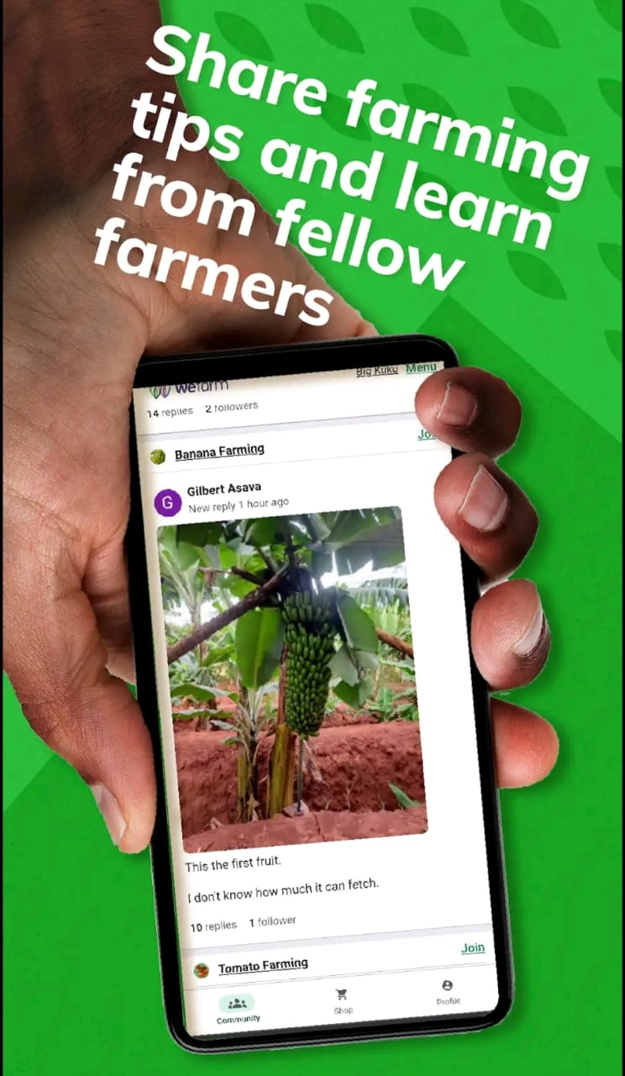

Figure 2‑1 Wefarm Mobile Feed

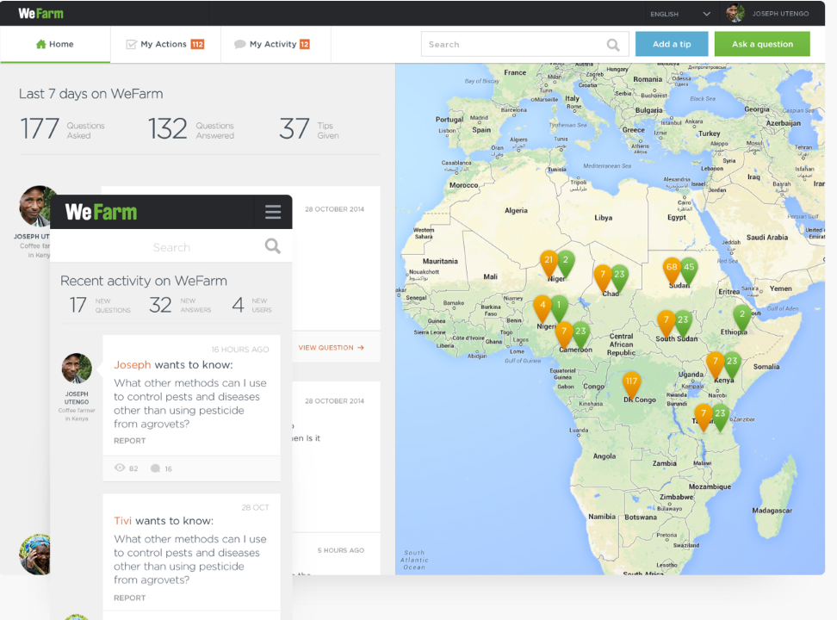

Figure 2‑2 WeFarm Map Webview

### iCow

iCow is a mobile phone-based agricultural platform that provides farmers with information on animal husbandry and crop management. It delivers timely messages on best practices, market prices, and weather forecasts through SMS and voice messages. iCow helps farmers improve productivity and profitability by offering actionable advice and reminders, as seen in Figure 2.3

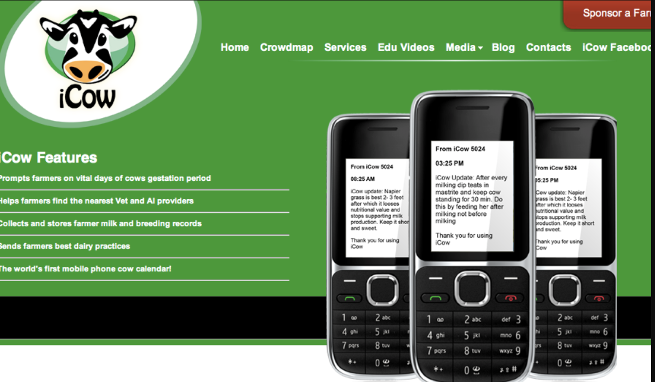

Figure 2‑3 Icow Landing Page

### DigiFarm

DigiFarm, developed by Safaricom, is a comprehensive platform that offers agricultural advice, access to financial services, and input supplies to smallholder farmers. Farmers can register for free and receive tailored information on farming practices, market prices, and financial products. DigiFarm aims to empower farmers by providing them with the necessary tools and knowledge to improve their yields and income.

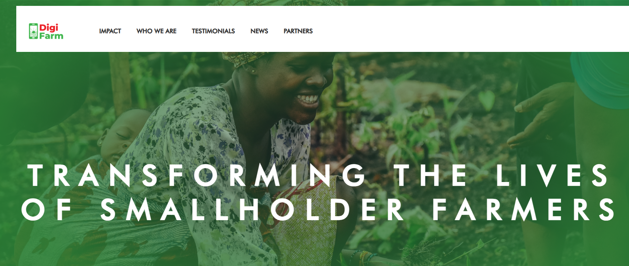

Figure 2‑4 DigiFarm Saf Landing page

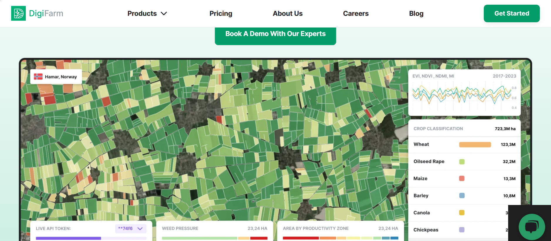

Figure 2‑5 Digifarm Demo Builder

### eSoko

eSoko is a digital platform that provides market information, weather updates, and agricultural tips to farmers via SMS. The platform helps farmers make informed decisions about when to plant, harvest, and sell their produce. By providing real-time information, eSoko aims to enhance agricultural productivity and market access for smallholder farmers.

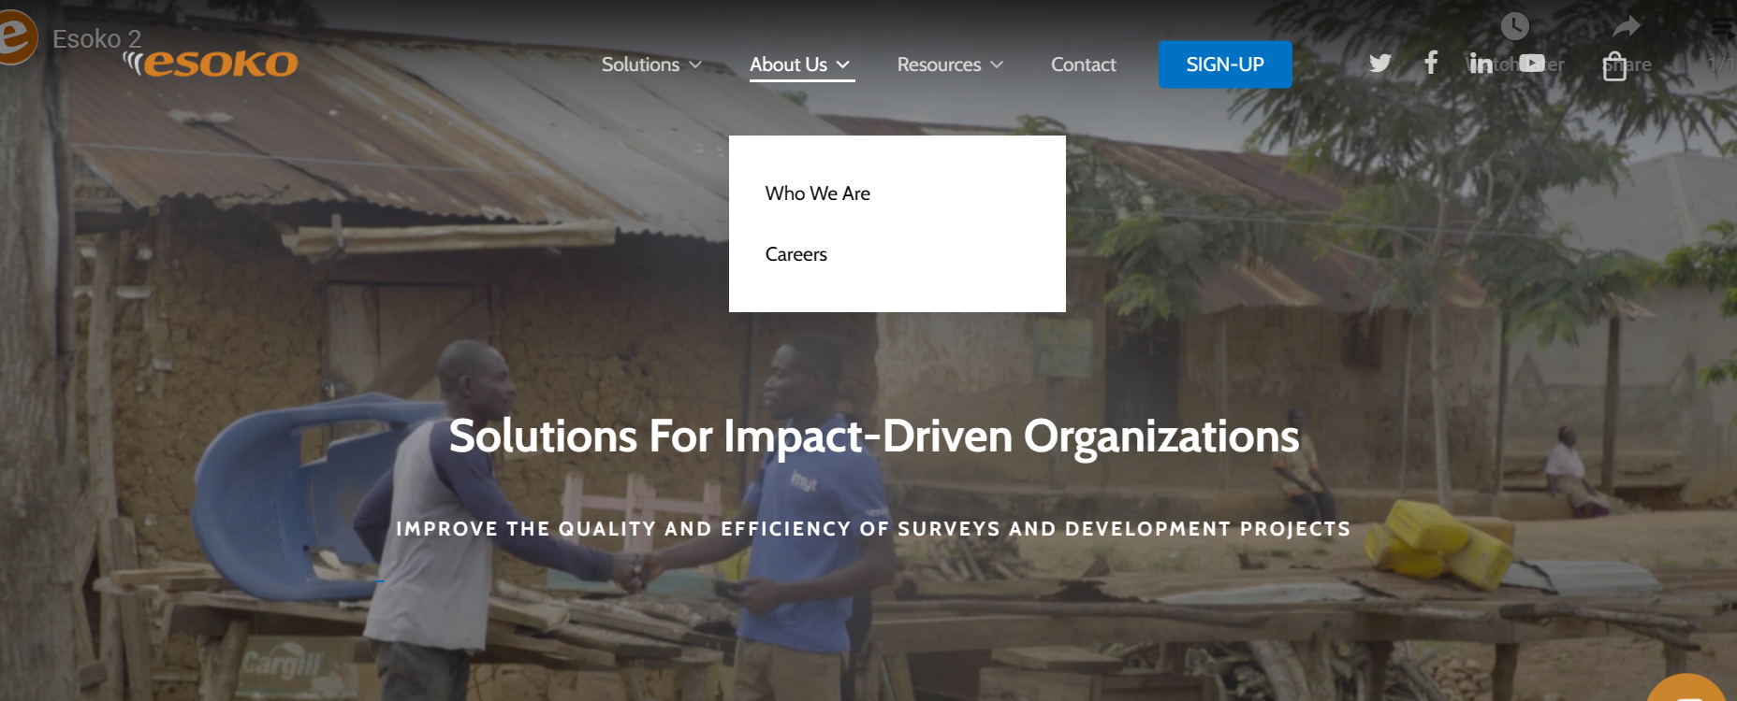

Figure 2‑6 eSoko Landing Page

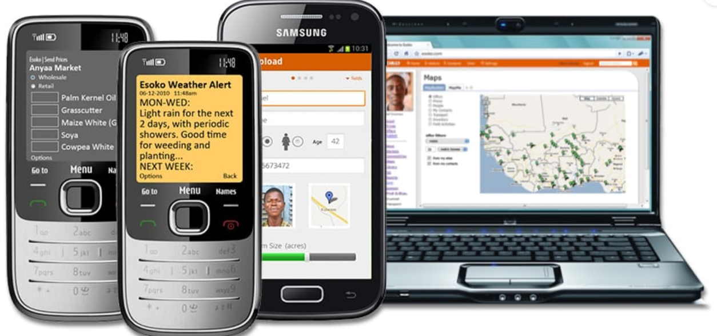

Figure 2‑7 eSoko Web, Mobile and SMS

## Gaps in Existing Solutions

While the above solutions have made significant strides in improving agricultural knowledge dissemination, several gaps remain:

### Limited Real-time Interaction

Most existing platforms lack real-time interaction capabilities, which can delay the provision of crucial information during urgent situations, such as pest outbreaks or sudden weather changes.

### Scalability and Coverage

The scalability of these platforms is often limited by infrastructure and resource constraints. Ensuring that all farmers, especially those in remote areas, have access to these services remains a challenge.

### Customization and Personalization

Many existing solutions offer generalized information that may not be fully relevant to individual farmers' specific contexts. There is a need for more personalized and context-specific advice to address the unique challenges faced by each farmer.

### Language and Accessibility

Addressing the language and literacy barriers more effectively is crucial. Many platforms do not offer multilingual support or content designed for low-literacy users, limiting their reach and effectiveness.

## Applied Techniques

The Arifu platform will employ various techniques to address these gaps and enhance agricultural knowledge dissemination.

### SMS and Mobile Application Integration

Arifu will leverage both SMS and a mobile application to deliver agricultural information, ensuring that farmers with basic mobile phones can access the service. The integration of machine learning algorithms will enable the platform to provide personalized content based on the individual needs and preferences of farmers.

### Real-time Data and Analytics

The platform will utilize real-time data analytics to offer timely advice and alerts. This will include weather updates, pest and disease warnings, and market price fluctuations. By providing real-time information, Arifu aims to empower farmers to make informed decisions promptly.

### Multilingual Support and User-friendly Interface

To overcome language and literacy barriers, Arifu will offer content in English and swahili languages and use simple, easily understandable jargon. The user interface will be designed to be intuitive and accessible, ensuring that even low-literacy farmers can navigate the platform effectively.

### Comprehensive Training Modules

Arifu will include detailed training modules covering a wide range of agricultural topics. These modules will be designed to be concise and practical, providing farmers with step-by-step guidance on best practices for crop and livestock management.

## Conceptual Framework

Users can register for Arifu either through the mobile app or the SMS platform. For the mobile app, users download the app, register, and provide their personal information. For the SMS platform, users send a USSD code and provide their information via SMS. All user data is then stored in a central database.

Content for Arifu is created and curated, including pictures, notes, and captions, to develop educational materials in both Swahili and English. This content is delivered through interactive modules, videos, and quizzes on the mobile app, while the SMS platform sends text messages with advice, reminders, and quizzes. The system integrates real-time data to send personalized updates and alerts. Periodic quizzes and feedback are collected via the app or SMS, awarding badges or certifications. Machine learning algorithms analyze user data to personalize content and advice, while user engagement is monitored, and reports are generated for continuous improvement.

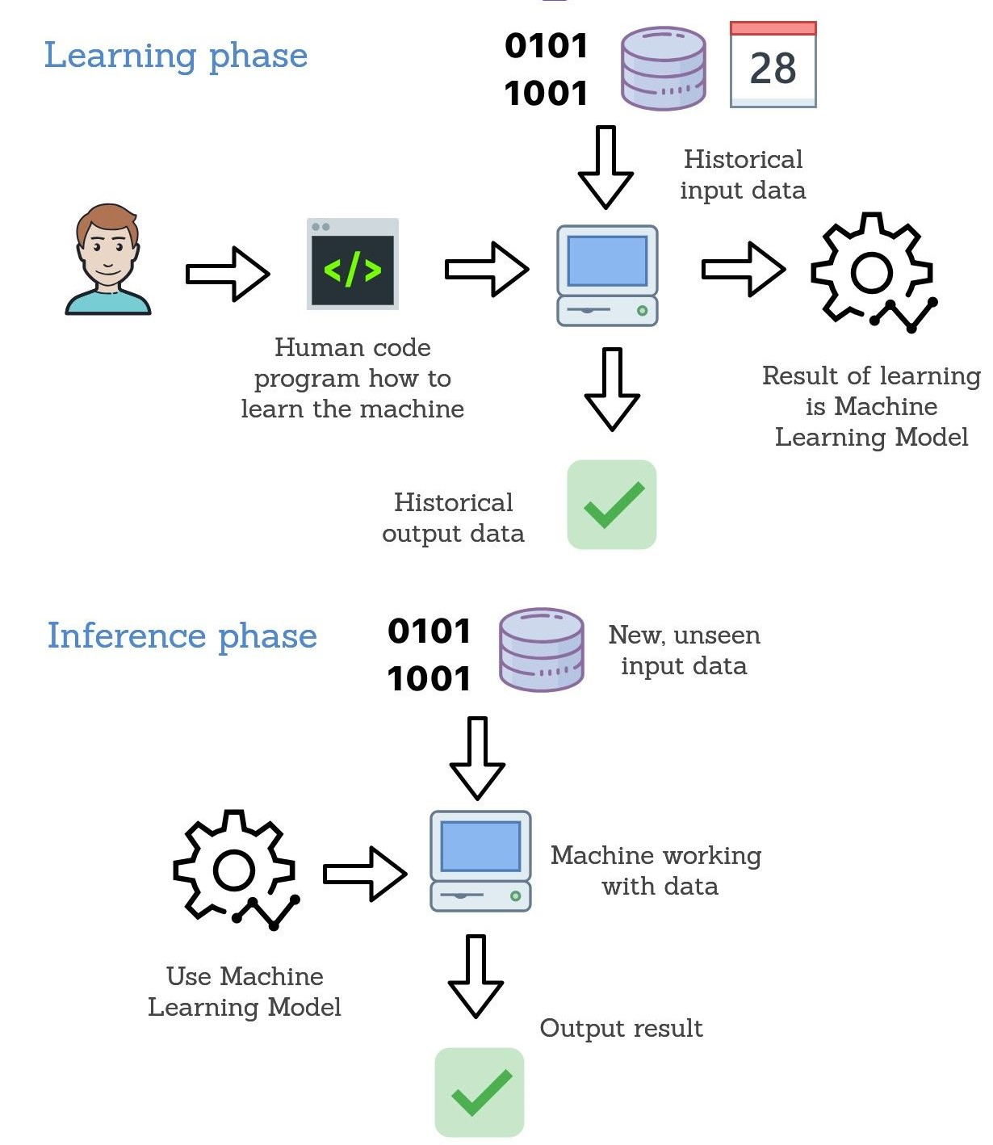

Figure 2‑8 Arifu Conceptual Framework

# Methodology

## Introduction

This chapter presents the methodology that will govern the development process of the proposed system. It explains the software development approach to be used, indicating how it fits within the aims of the project. Additionally, this chapter covers strategies in system analysis and design to ensure a strong and scalable application. Finally, it points out the tools, technologies, and expected deliverables for driving the development process.

## Research Methodology

The proposed design for developing an Arifu system composed of both a disease detection application and the Laravel USSD application applies systematic, iterative research methodology. This would bring together both qualitative and quantitative approaches toward ensuring the technical feasibility of the designed system to meet the required standards of the users' demands. The methodology broadly outlines the following phases:

### Requirements Gathering

It involves the collection of detailed requirements from the stakeholders involved, such as farmers and agricultural extension officers, among other end-users. It entails:

1. **User Interviews:** Interviews to understand the challenges of the users in disease detection and access to agricultural information.
2. **Questionnaires:** The administration of questionnaires to capture user preference and expected functionality of the application.
3. **Review of Existing Solutions:** A review of similar systems is done for gap analysis and best practices that can be implemented.

### Planning

Planning forms the most crucial aspect that ensures successful development and deployment of the Arifu system. A detailed plan developed by the development team stipulates what features and functionalities will be delivered in each iteration to ensure the project remains within scope and on time.

For every requirement of the Arifu system, there will be a strong outline on the development, delivery, and integration of the features to be observed in the whole application. This planning phase encompasses these key aspects:

1. Feature Prioritization: This helps establish high-priority features necessary for the application, like identifying diseases in plants or enabling USSD menu navigation, to make sure development starts with the most important component.
2. Task Breakdown: Breaking down complex features into smaller, manageable tasks that can be completed within a single sprint.
3. Estimation of Timeline: Estimating timelines for each development task to ensure the project is on schedule.
4. Resource Allocation: Assigning team members to tasks based on expertise for maximum productivity.
5. Scheduling Integration: Clearly defining milestones for integrating the disease detection mobile app and the Laravel USSD platform.

## Design and Development tools

The development of the Arifu system involves leveraging modern tools and technologies to ensure efficiency, scalability, and robustness in both the Flutter-based plant disease detection application and the Laravel USSD application. Below is an outline of the key tools and technologies used in the design and development of each component:

### Design Tools

1. **Figma**
   * Used for creating wireframes, mockups, and user interface (UI) prototypes.
   * Ensures a consistent and intuitive design for the Flutter mobile application and the Laravel USSD interface.
2. **Adobe XD**
   * Provides additional design resources for enhancing UI/UX design, particularly for complex visual elements.
   * Facilitates design collaboration and stakeholder feedback loops.
3. **Lucidchart**
   * Used to create flowcharts and system diagrams for understanding the application's architecture and USSD flow logic.
   * Aids in visualizing interactions between system components.
4. **Postman**
   * Essential for designing and testing API integrations between the Flutter application and backend services and Africa’s talking with the Laravel Controllers.

### Development Tools

**For the Flutter Mobile Application**

1. **Flutter SDK**
   1. Provides a framework for building cross-platform applications.
   2. Utilized for implementing the disease detection functionalities and UI of the mobile app.
2. **Dart Language**
   1. Programming language used for writing efficient and maintainable code in the Flutter environment.
3. **TensorFlow Lite**
   1. Used for integrating the machine learning model for plant disease detection.
   2. Enables on-device inference for faster processing.
4. **Image Package (Dart)**
   1. Provides image preprocessing capabilities, such as resizing and normalization, critical for preparing images before model inference.
5. **Android Studio/Visual Studio Code**
   1. Primary Integrated Development Environments (IDEs) for coding, testing, and debugging the Flutter application.
6. **Teachable Machine and Jupyter Notebook(Colab)**
   1. Jupyter notebook was user to train the filtering binary model to prevent non-plant images from reaching the classification model.
   2. Teachable Machine by google was use to train the model using 50 epochs and tuning and was also used to introduce new classes of diseases.

**For the Laravel USSD Application**

1. **Laravel Framework**
   1. PHP-based framework used for building the USSD backend system.
   2. Provides tools for rapid application development and efficient routing.
2. **PHP 8.x**
   1. Programming language used for developing custom logic and business rules for the USSD application.
3. **MySQL**
   1. Database system for managing user data, session records, and application metadata.
   2. Ensures reliable data storage and retrieval for the USSD service.
4. **Artisan CLI**
   1. Used for managing migrations, generating controllers, and creating custom commands in Laravel.
5. **Ngrok**
   1. A tunneling tool used during development to expose the local Laravel server to the internet for testing USSD integrations.
6. **Postman**
   1. Aids in testing REST APIs that support the Laravel USSD application.
7. **Git/GitHub**
   1. Version control tools used for collaborative development, code management, and deployment tracking.
8. **Kaggle**
   1. For sourcing of datasets of images of disease-ridden plants.

## Research Paradigm

The research paradigm that the development of the Arifu system followed incorporates both qualitative and quantitative approaches to ensure holistic understanding on the part of user needs and technical feasibility.

1. **Quantitative Approach**
2. By measurable outcome, the model accuracy of plant disease detection, performance metrics related to USSD application
3. The data was collected by testing and the user interaction log to prove the efficiency, scalability, and reliability of the system.
4. **Qualitative Approach**
5. Emphasizes user feedback and usability testing to improve the experience of the user.
6. Interviews and surveys are conducted to obtain insights into user preferences and satisfaction.
7. **Mixed Methods**
8. Combines quantitative metrics with qualitative feedback to create a well-rounded perspective on system performance and user adoption.
9. Ensures both technical and human-centered considerations are taken into account during development.

## Methods

The development process followed in the Arifu system is done through an orderly combination of agile methodology and machine learning workflows. This involves gathering requirements, iterative design, development, testing, and deployment. Preprocessing, model training, testing, and validation were the steps included in building the disease detection model. In the Laravel USSD application, state-based navigation design and backend integration are followed to enable user interactions without glitches.

## Model Training and Classes

The Convolutional Neural Network architecture puts into service for training an image classification task in plant disease detection. Image preprocessing for training involves the following:

1. Pre-processing images in constant dimensions 224x224 and normalization.
2. Feeding the data into the model, iteratively adjusting the weights to minimize the loss function.
3. Improve the model by employing methods such as gradient descent and early stopping to avoid overfitting.

## Training dataset

Training on high-quality labeled images of healthy and diseased conditions in plants includes but is not limited to:

1. Open-source datasets provided from websites such as Kaggle or PlantVillage.
2. Custom-collected images from agricultural extension services and farmers.
3. The dataset is balanced, and all classes are represented with equal priority to reduce bias in the model.

## Sample

The sample is about 18,230 plant images, distributed across different categories of diseases and healthy plants. Each category will contain a representative number of images that supports model generalization and accuracy.

Sample data for the Laravel USSD application include user interaction scenarios and simulated transactions in order to verify functionality and usability.

## Training and Testing

The data is divided into three sets:

1. Training Set-70%

This will be used for training the model and weight adjustment.

1. Testing Set-20%

It finds its application in evaluating the model on unseen data.

1. Validation Set-10%

During training, this data will be used to tune hyperparameters and monitor overfitting.

For the Laravel USSD app, testing includes unit testing for backend functionality and integration testing to ensure seamless user flow.

## Validation Experiment: population, setup

### Population

The validation experiment targets farmers and agricultural stakeholders, focusing on a heterogeneous group representing diverse regions and crops.

### Setup

1. The testing of the plant disease detection model, therefore, involves actual tests with real farmers uploading images taken from their crops; the result is cross-checked against experts' diagnoses.
2. Real users are used, interacting through feature phones with the USSD application to verify its reliability and usability.
3. Other metrics analyzed include model accuracy, precision, and recall to refine the system further. The feedback from the end-users on the USSD app is considered.

# System Analysis and Design

## Introduction

The basis of this chapter is the analysis and design techniques that were applied in the development of the Arifu system. In this chapter, both functional and non-functional requirements of the plant disease detection application and Laravel-based USSD system are discussed, together with diagrammatic representation to clearly explain the interaction and integration between various system components.

Further on, this chapter looks into the OOAD methodology used in structuring the system: system requirements, user workflows, and interface designs. This application design is represented with the help of UML diagrams such as use case diagrams, class diagrams, and activity and sequence diagrams.

## System Requirements

System requirements refer to the necessary configurations, both hardware and software, that ensure a smooth and efficient operation of the system. If these requirements are not met, it can result in issues during installation or cause performance degradation. These problems may prevent the application from functioning properly, leading to malfunctions or crashes. In this section, we will review both functional and non-functional requirements that are essential for the smooth operation of the Arifu system and its associated applications.

### Functional Requirements

Functional requirements define the specific functionalities and features that the system must include for users to accomplish their tasks. These requirements describe the expected system behavior under different conditions. Below are the key functional requirements for both the disease detection Flutter app and the Laravel USSD app:

I. **User Authentication Module**

1. The system must allow users to register and log in using their email or phone number.
2. Passwords must be hashed for security using SHA-256 or a similar secure hashing algorithm to ensure the safety of user data.
3. Users should be able to reset their passwords securely through a verified email or phone number.

II. **Disease Detection Module**

1. The Flutter app must allow users to upload images of plants for disease detection.
2. The system must preprocess the image (resize and normalize) and pass it through the trained machine learning model for classification.
3. The app must return disease predictions with a confidence score and suggestions for treatment, if applicable.

III. **USSD Interaction Module**

1. The Laravel USSD system must handle user input through a menu-driven USSD interface.
2. The system should allow users to request information on plant diseases, treatment options, and preventive measures via text-based interaction.
3. The USSD menu must be navigable with simple key presses (e.g., 1 for disease identification, 2 for treatment options).

IV. **Data Synchronization Module**

1. The Flutter app should sync user data, including uploaded images and results, with a cloud database to ensure it is accessible across different devices.
2. The Laravel system must synchronize with external databases to provide real-time information to users querying the system.

V. **Reporting and Feedback Module**

1. The system must allow users to provide feedback on disease detection results, including the option to report inaccurate predictions.
2. The system must generate periodic reports for the administrator, summarizing user activity, common diseases detected, and treatment requests.

### Non-Functional Requirements

Non-functional requirements describe the overall qualities of the system that ensure it operates efficiently and provides a good user experience. These are general attributes that contribute to the system's overall performance, reliability, and scalability. Below are the key non-functional requirements for the Arifu system:

I. **Performance**

1. The system must load the disease detection results within 5 seconds after image submission.
2. The system should handle up to 10,000 concurrent users without performance degradation.

II. **Scalability**

1. The USSD system must be able to handle an increasing number of requests without compromising speed or accuracy.
2. The disease detection app should be able to scale to support additional models or features in the future.

III. **Usability**

1. The user interface of both the Flutter app and the USSD menu must be simple and intuitive, allowing users with minimal technical experience to navigate and operate the system with ease.

IV. **Reliability**

1. The system must not crash under normal usage and should handle errors gracefully.
2. Backup mechanisms should be in place to protect user data in case of unexpected failures.

V. **Security**

1. The system must implement secure communication protocols, such as HTTPS, to ensure user data is protected during transmission.
2. All sensitive data (e.g., passwords, personal information) should be encrypted both at rest and in transit.

VI. **Privacy**

1. User data, including images and feedback, must be handled in compliance with relevant privacy regulations (e.g., GDPR).
2. The system should ensure that personal information is never shared without explicit consent.

## System Analysis Diagrams

In this section, we will focus on presenting the system analysis and design for the Arifu disease detection app and the Laravel USSD application. These diagrams serve as visual representations of the various components of the system and their interactions.

### Context Diagram

A context diagram provides an overview of the system and its external interactions. It shows how the system interfaces with external entities, such as users, databases, or other systems.

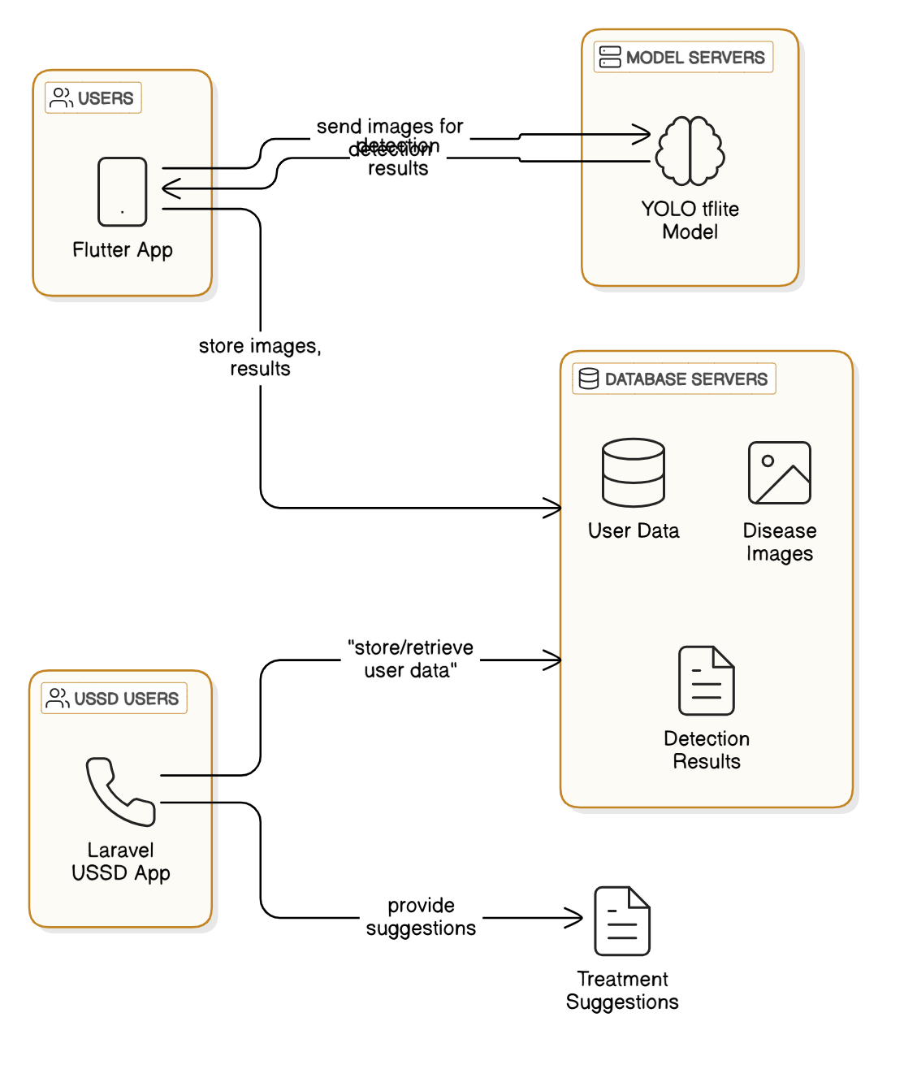

Figure 4‑1 Arifu Context Diagram

**Arifu Disease Detection Tool by AI/Flutter App**

The user takes a clear picture of the plant and feeds it into the Arifu disease detection app through the Flutter frontend. It gets processed in the app, passing through the trained model of disease detection using machine learning in classifying the condition of the plant. The result is returned to the app, showing the detected disease, if any, and some suggestions for treatment through installed browser. It will then display the name of the disease, causes, and recommended actions on how to treat or prevent the disease, thus giving immediate feedback with valuable insights on how to care for the plant.

**USSD Menu Interaction - Laravel Application**

The user calls a certain USSD code for a arifu, which opens the main menu and gives the user some options to choose from. On the other hand, arifu employees view and manage the ussd menu and programs for education.

### Use Case Diagram

A use case diagram visually represents the interaction between users and the information system.

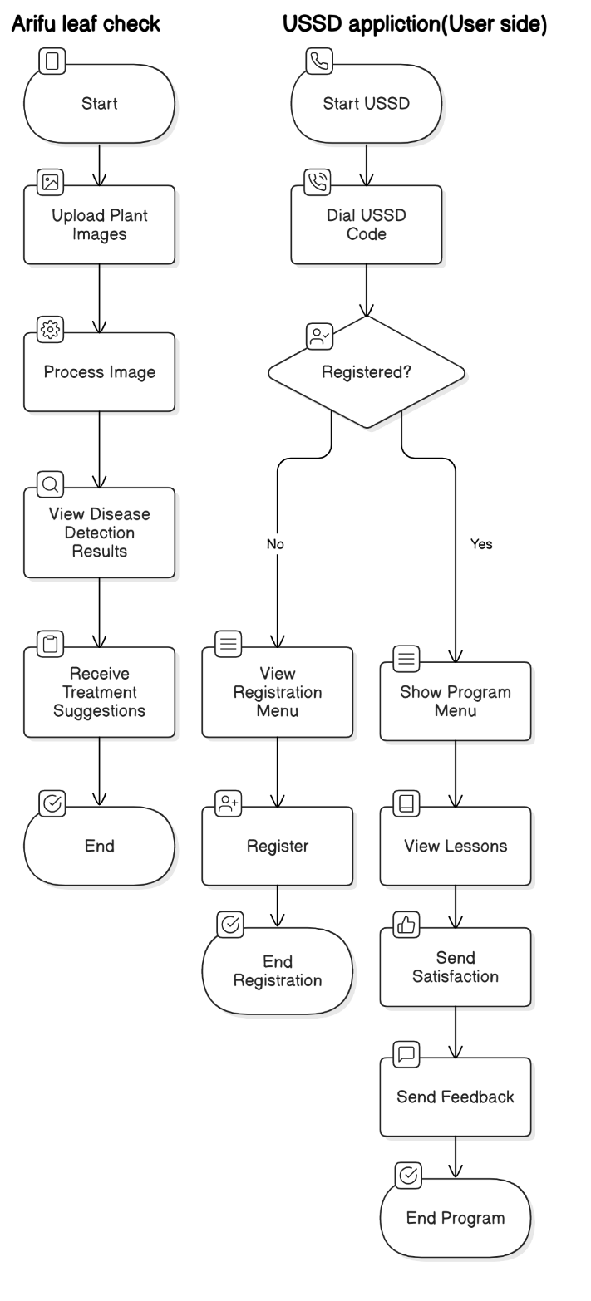

Figure 4‑2 Both systems use case diagrams

### Sequence Diagram

A sequence diagram captures the order of interactions between system components over time. It shows how different objects or modules collaborate to perform a task.

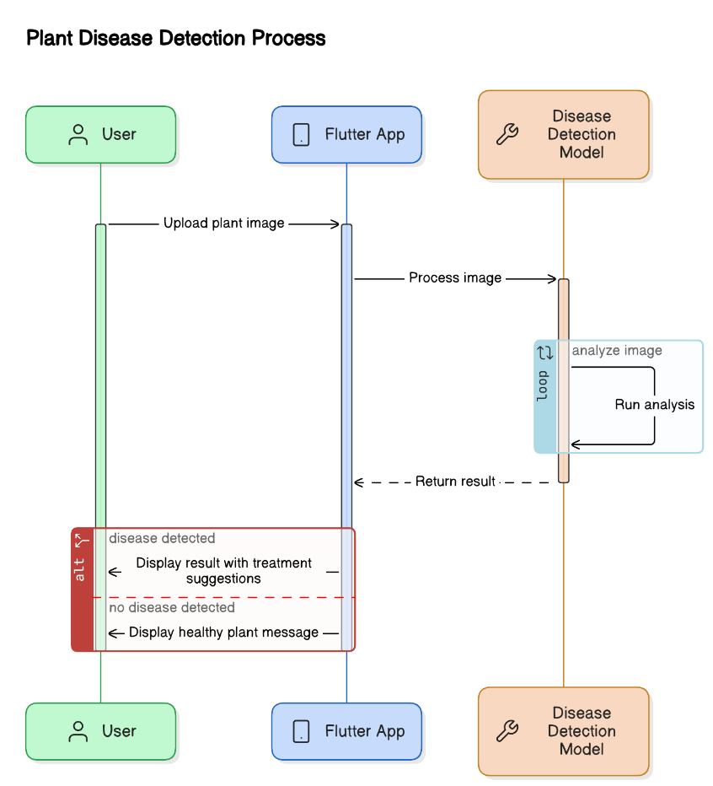

Figure 4‑3 System sequence diagram for Arifu LeafCheck

The user launches the Plant Disease Detection app and selects or captures an image of a plant using the device's camera or gallery. The app preprocesses the image, checking if it contains enough green to be a plant, and then passes it to a machine learning model for disease detection. If the image is recognized as a plant, the model predicts the disease and displays the result with the confidence level. The app also provides the option to view precautions and further details about the disease, along with a "Learn More" button that directs the user to browser for disease treatment and management.

### Entity Relationship Diagram

An ERD models the relationships between different entities in the system. It defines how user data, images, and disease results interact with each other within the database.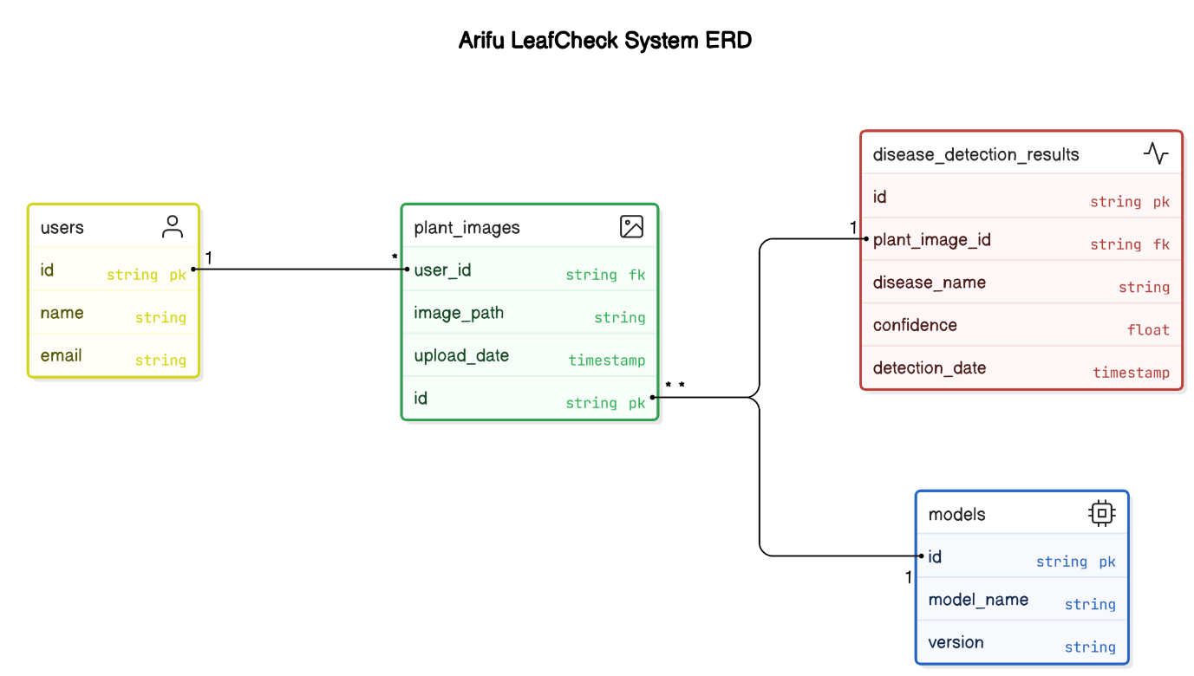

Figure 4‑4 Arifu LeafCheck ERD

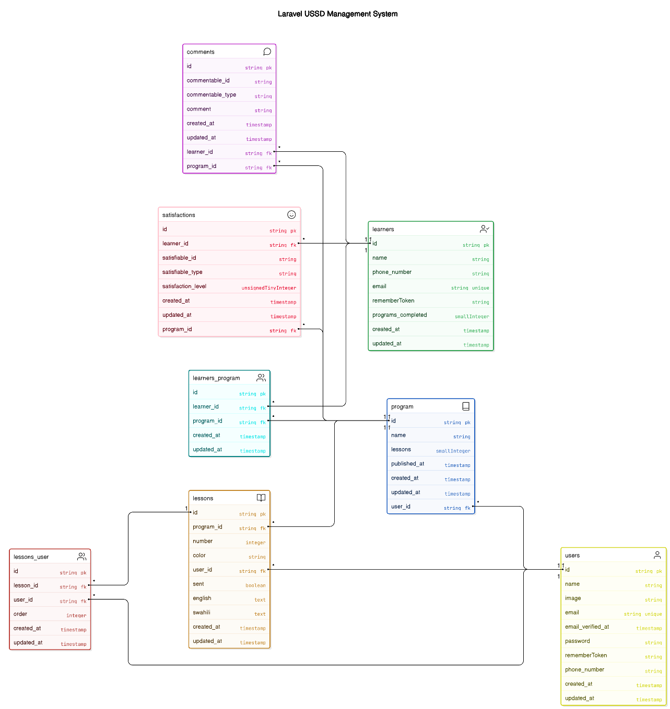

Figure 4‑5 Laravel USSD management System

## System Design

In this section, we will delve into the system design of the **Arifu Mobile Application** and the **USSD Platform**. This will highlight key interface layouts and design elements within the system. These are visual representations of how users will interact with the system, and they serve as blueprints for the actual user interfaces. By outlining the Figma designs, we aim to provide clarity on the structure and user experience (UX) of both the mobile and USSD applications.

### USSD Platform Design

This will provide the administrators and user to manage the USSD requests, edit, delete and create programs and lessons, analytics and more. All are figma designs:

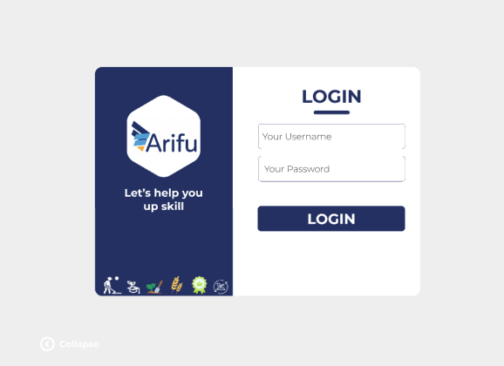

Figure 4‑6 Login page for The Ussd DashBoard

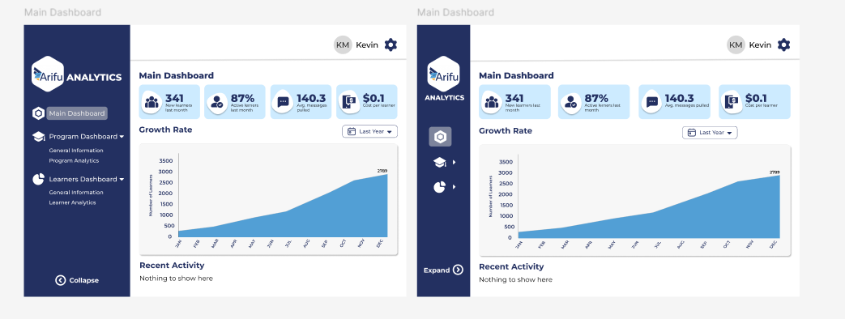

Figure 4‑7 Main Dashboard after Login

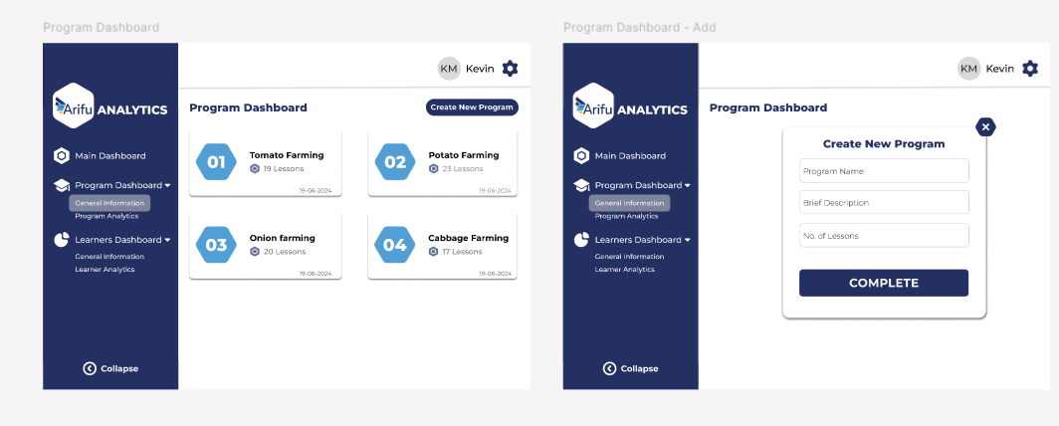

Figure 4‑8 Program Dashboard

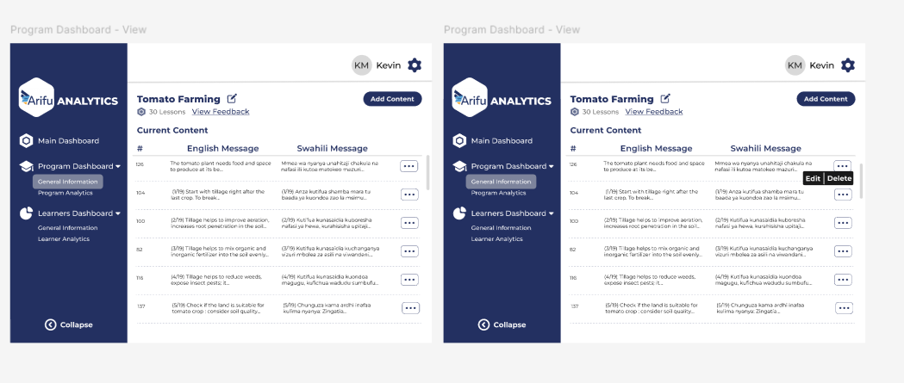

Figure 4‑9 Lessons Dashboard

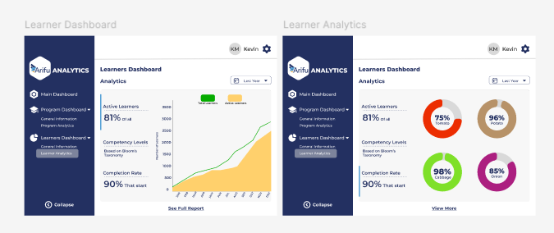

Figure 4‑10 Learner Analytics

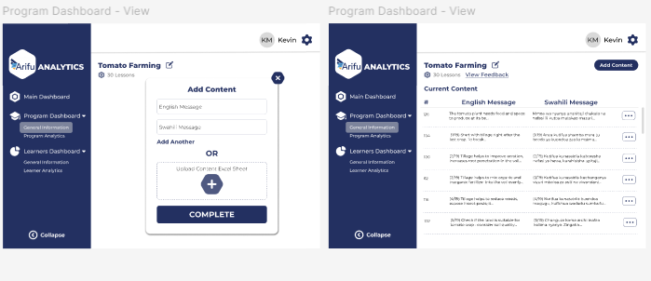

Figure 4‑11 Lessons Dashboard

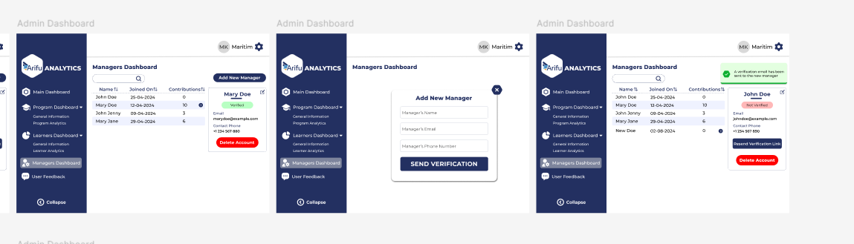

Figure 4‑12 Manager Creation Dashboard

### Arifu Leaf Check Designs

A general overview of the pages necessary for the proposed tool:



Figure 4‑13 LandPage on opening app

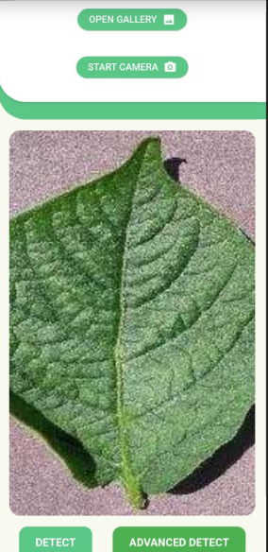

Figure 4‑14 Resizing Image after capturing

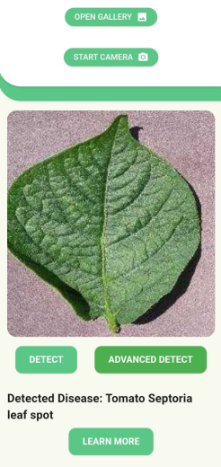

Figure 4‑15 Results Display By the tflite model

### System Architectures

## System Deliverables and Milestones

### System Proposal

### User Module

### HGRD Model

## System Development Tools and Techniques

### Google’s Teachable Machine & Jupyter Notebook

### Kaggle

### Android Studio

### Notion

### GitHub

### Visual Studio

### Africa’s Talking API and Sandbox

### Scholars USSD Development Module

# System Implementation and Testing

## System Implementation

### The Plant Disease Recognition Model

### Object Filtration Model

### Arifu Leaf Check Application

### WestSeed Ussd Database Responses

### WestSeed Ussd Management Frontend

### WestSeed Ussd Management Backend

### Africa’s Talking & Scholars Implementation

## System’s Manual

## System Testing

### Functional Testing

### Non-Functional Testing

# Conclusion and Recommendation for Future Work

## Conclusions

## Recommendations

## Future Work

# **References**

Mgonja, K. M. (2019). Access to Agricultural Information by Smallholder Farmers in Tanzania. *FACTORS INFLUENCING ACCESS TO AGRICULTURAL INFORMATION BY* , 13-19.

Msoffe, P. L. (2019). Challenges in Agricultural Extension Service Delivery in Tanzania: A Case Study of Selected Districts. *African Journal of Agricultural Research*, 14(3), 139-150.

Mwalukasa, N. (2019). Agricultural Information Sources Used for Climate Change Adaptation in Tanzania. *Library Philosophy and Practice (e-journal)*, 951.

Technoserve Ltd. (2021, february 26). *TechnoServe*. From Annual Report: Supporting Farmers in Tanzania." Available at TechnoServe: https://www.technoserve.org/2020-annual-report/

Appendix

Appendix A: Gantt Chart

Appendix A: Gantt Chart

Appendix A: Gantt Chart

Appendix A: Gantt Chart

Appendix A: Gantt Chart

Appendix A: Gantt Chart

Appendix A: Gantt Chart